Assignment # 07

Spring 2024
Submitted by:
Waqas khan
Submitted to;
Syed Adeel shah

Class Section: A
“On my honor, as student of University of Engineering and Technology, I have neither given nor received unauthorized assistance on this academic work.”
Student Signature: ______________
Month, Day, Year (Dec 08 2024)
Department of Computer Science
University of Engineering and Technology, Peshawar.
Task#01:
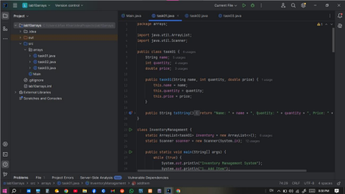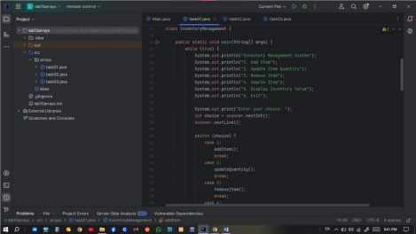
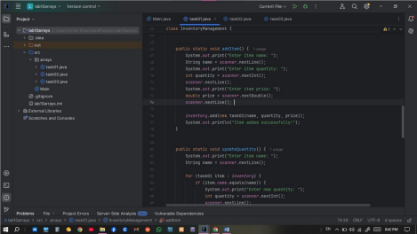
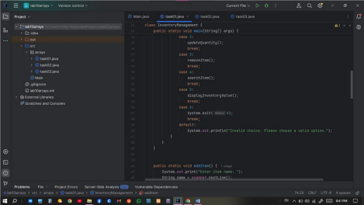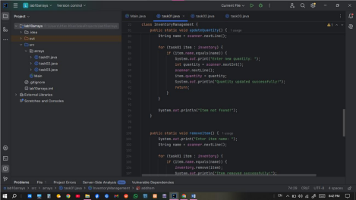
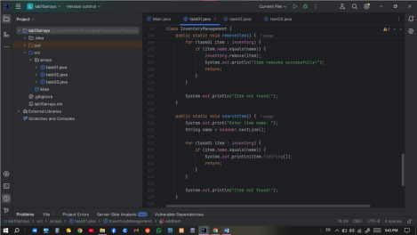
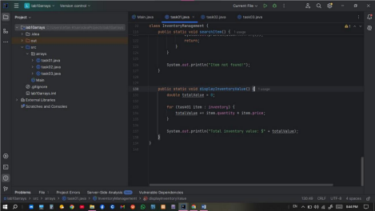
O utput:
Task#02 :
Output:
Task#03 :
Output:

